Experiment 6

Inference of Q Factor of Rectangular Cavity Resonator for TE101 Mode with Dimensions a, b and c
Test Case 1
A rectangular cavity resonator operating in the TE101 mode is made of copper (σ = 5.8×10⁷ S/m). Starting from a = 4 cm, b = 3 cm and varying the cavity length c from 8 cm to 12 cm, determine how the Q-factor changes and explain the relationship between the dimension c and the Q-factor.
Code -
clear; clc;
sigma=5.8*10^7; Uo=4*%pi*10^-7; V=3*10^8;
a=0.04; b=0.03;
cvals=[0.08 0.09 0.10 0.11 0.12];
for i=1:5
c=cvals(i);
f101=(V/2)*sqrt((1/a)^2+(1/c)^2);
d=sqrt(1/(%pi*f101*Uo*sigma));
Q=(a^2+c^2)*a*b*c/(d*(2*b*(a^3+c^3)+a*c*(a^2+c^2)));
printf('c=%.2f cm f101=%.4f GHz Q=%.2f\n',c*100,f101*10^-9,Q);
end
Output:
Fixed: a = 4.0 cm, b = 3.0 cm (Copper, σ = 5.8×10⁷ S/m)
a (cm) | b (cm) | c (cm) | f101 (GHz) | Q Factor - Sim | Q Factor - Theory
4.0 | 3.0 | 8.0 | 4.1926 | 12508.07 | 12508.07
4.0 | 3.0 | 9.0 | 4.1037 | 12309.00 | 12309.00
4.0 | 3.0 | 10.0 | 4.0389 | 12142.94 | 12142.94
4.0 | 3.0 | 11.0 | 3.9902 | 12005.65 | 12005.65
4.0 | 3.0 | 12.0 | 3.9528 | 11892.11 | 11892.11
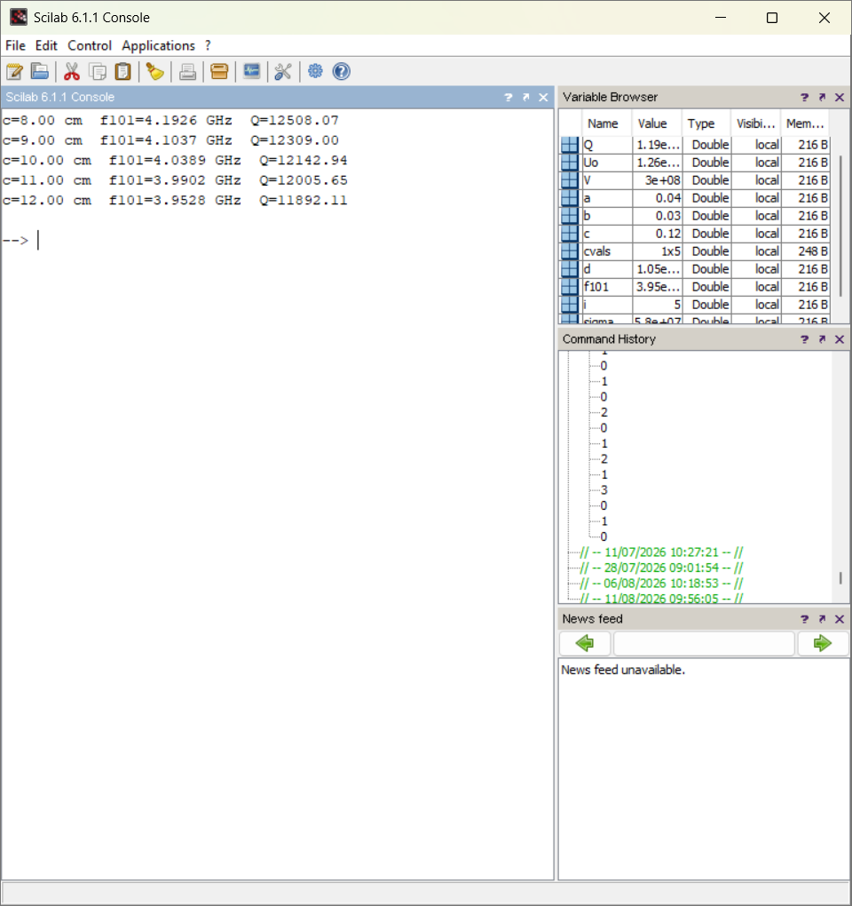
Result:
As the cavity length c is increased from 8 cm to 12 cm (with a = 4 cm, b = 3 cm held fixed), the resonant frequency f101 decreases and the Q-factor steadily decreases from 12508 to 11892. This is because increasing c lowers the surface-to-volume ratio efficiency of the TE101 mode and reduces the resonant frequency, both of which reduce the stored-to-dissipated energy ratio represented by Q.
Test Case 2
Using the dimension sets from Test Case 1, determine which combination of a, b and c yields the maximum Q-factor and explain why.
Code -
clear; clc;
sigma=5.8*10^7; Uo=4*%pi*10^-7; V=3*10^8;
a=0.04; b=0.03;
cvals=[0.08 0.09 0.10 0.11 0.12];
Qmax=0; best=0;
for i=1:5
c=cvals(i);
f101=(V/2)*sqrt((1/a)^2+(1/c)^2);
d=sqrt(1/(%pi*f101*Uo*sigma));
Q=(a^2+c^2)*a*b*c/(d*(2*b*(a^3+c^3)+a*c*(a^2+c^2)));
if Q>Qmax then Qmax=Q; best=c; end
end
printf('Maximum Q = %.2f at c = %.2f cm',Qmax,best*100);
Output:
a (cm) | b (cm) | c (cm) | Q Factor - Simulation | Q Factor - Theoretical
4.0 | 3.0 | 8.0 | 12508.07 | 12508.07
4.0 | 3.0 | 9.0 | 12309.00 | 12309.00
4.0 | 3.0 | 10.0 | 12142.94 | 12142.94
4.0 | 3.0 | 11.0 | 12005.65 | 12005.65
4.0 | 3.0 | 12.0 | 11892.11 | 11892.11
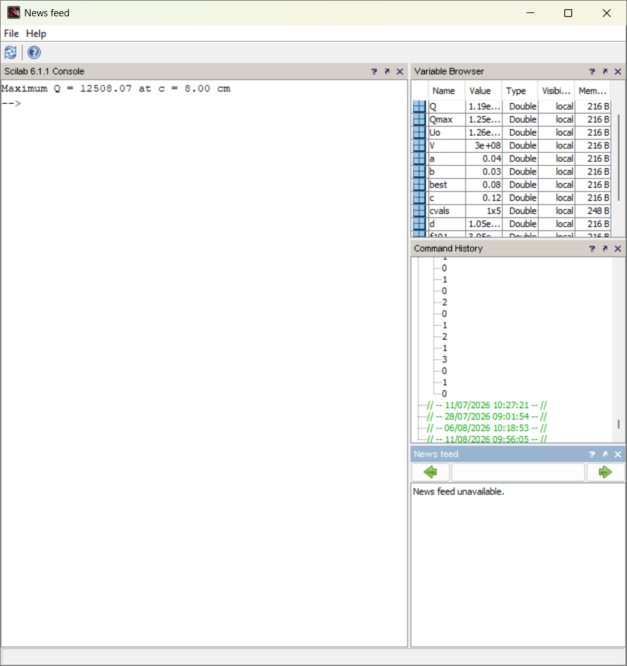
Result:
Among the tested dimension sets, the combination a = 4 cm, b = 3 cm, c = 8 cm gives the highest Q-factor (12508.07). The smallest cavity length c gives the highest resonant frequency and the most favourable ratio of stored volume to dissipating wall surface area for the TE101 mode, resulting in the maximum Q-factor.
Test Case 3
Fix b = 4 cm and c = 10 cm, and vary a between 4 cm and 6 cm. Determine how the Q-factor changes and comment on the sensitivity of Q to the dimension a.
Code -
clear; clc;
sigma=5.8*10^7; Uo=4*%pi*10^-7; V=3*10^8;
b=0.04; c=0.10;
avals=[0.040 0.045 0.050 0.055 0.060];
for i=1:5
a=avals(i);
f101=(V/2)*sqrt((1/a)^2+(1/c)^2);
d=sqrt(1/(%pi*f101*Uo*sigma));
Q=(a^2+c^2)*a*b*c/(d*(2*b*(a^3+c^3)+a*c*(a^2+c^2)));
printf('a=%.2f cm f101=%.4f GHz Q=%.2f\n',a*100,f101*10^-9,Q);
end
Output:
Fixed: b = 4.0 cm, c = 10.0 cm
a (cm) | b (cm) | c (cm) | f101 (GHz) | Q Factor - Sim | Q Factor - Theory
4.0 | 4.0 | 10.0 | 4.0389 | 13570.95 | 13570.95
4.5 | 4.0 | 10.0 | 3.6553 | 14004.09 | 14004.09
5.0 | 4.0 | 10.0 | 3.3541 | 14366.54 | 14366.54
5.5 | 4.0 | 10.0 | 3.1126 | 14665.85 | 14665.85
6.0 | 4.0 | 10.0 | 2.9155 | 14908.60 | 14908.60
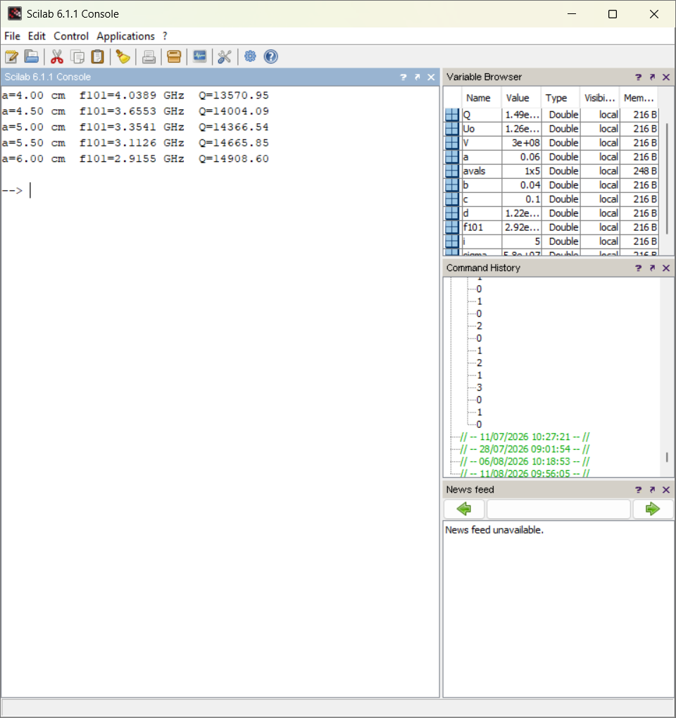
Result:
As a increases from 4 cm to 6 cm (b = 4 cm, c = 10 cm fixed), the Q-factor rises steadily from 13571 to 14909, although the resonant frequency drops. The rate of increase in Q flattens slightly at larger a, showing that Q is moderately sensitive to a but with diminishing returns. In practical cavity design, the dimension along which the dominant field variation occurs (here a, in the x-direction for TE101) is usually the most critical one to optimise for achieving a high Q-factor, since it directly sets the mode's resonant condition and its associated wall-loss surface area.
Test Case 4
Fix a = 5 cm and c = 10 cm, and vary b (the y-axis dimension) between 3 cm and 5 cm. Analyze how the Q-factor changes with b.
Code -
clear; clc;
sigma=5.8*10^7; Uo=4*%pi*10^-7; V=3*10^8;
a=0.05; c=0.10;
bvals=[0.030 0.035 0.040 0.045 0.050];
for i=1:5
b=bvals(i);
f101=(V/2)*sqrt((1/a)^2+(1/c)^2);
d=sqrt(1/(%pi*f101*Uo*sigma));
Q=(a^2+c^2)*a*b*c/(d*(2*b*(a^3+c^3)+a*c*(a^2+c^2)));
printf('b=%.2f cm Q=%.2f\n',b*100,Q);
end
Output:
Fixed: a = 5.0 cm, c = 10.0 cm (f101 = 3.3541 GHz, independent of b for TE101)
a (cm) | b (cm) | c (cm) | Q Factor - Simulation | Q Factor - Theoretical
5.0 | 3.0 | 10.0 | 12639.79 | 12639.79
5.0 | 3.5 | 10.0 | 13571.93 | 13571.93
5.0 | 4.0 | 10.0 | 14366.54 | 14366.54
5.0 | 4.5 | 10.0 | 15051.97 | 15051.97
5.0 | 5.0 | 10.0 | 15649.27 | 15649.27
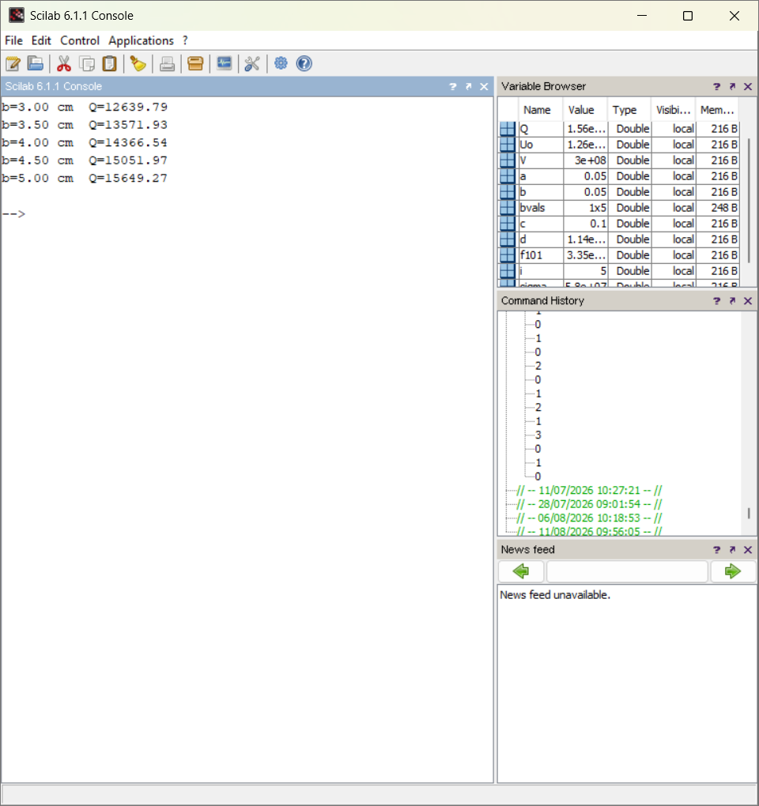
Result:
Increasing b from 3 cm to 5 cm (with a = 5 cm, c = 10 cm fixed) raises the Q-factor from 12640 to 15649, since the TE101 resonant frequency does not depend on b, so increasing b only adds cavity volume without adding additional conducting wall-loss area in the field-varying directions, improving the volume-to-loss ratio and hence the Q-factor.

